



HelpNow User Guide

What is Brainfuse?
Brainfuse is based in NYC and for over a decade, has developed and provided virtual learning solutions for schools, libraries, colleges, and universities. Our philosophy is anchored in adherence to high standards and user-centered technology to build a better educational experience for learners of diverse backgrounds. Brainfuse helps students and job seekers reach their goals by connecting them with qualified eTutors and job coaches anytime, anywhere. Users can also initiate and organize online meetings for peer-to-peer learning. The Brainfuse learning platform gives power to students and job seekers to manage outcomes better by seamlessly integrating the latest online technology.

Who are your tutors?
Brainfuse tutors are screened, trained, and managed directly by Brainfuse. Our tutors are recruited from a diverse tutoring pool and include a mix of professional tutors, retired instructors, graduate students and college faculty members. Only tutors with proven backgrounds in tutoring/teaching in their respective fields are hired by Brainfuse. Over 80% of tutors have a Master’s degree or a Ph.D. in their field.

Brainfuse regularly reviews and updates its tutor recruiting, training and monitoring procedures to provide the highest possible online tutoring experience for students. We have a unique live monitoring system where tutor interaction with students is reviewed by a live monitor and immediate feedback is given for an ongoing professional development.

- SYSTEM REQUIREMENTS
Windows
Windows 95 and above
Active Internet connection
Mac
Mac OS X and above
Active Internet connection
- BRAINFUSE TECHNICAL SUPPORT
Send an email to support@brainfuse.com or call toll-free at 1-866-272-4638, Ext. 510.

Brainfuse HelpNow

Personalized eLearning
Brainfuse HelpNow is an all-in-one suite of tutoring services designed for a wide range of academic needs whether it’s tackling a tough homework problem, mastering a particular topic, or writing a paper. HelpNow services include expert academic tutoring and self-study tools to empower users to study at their own pace or collaborate with peers and teachers. Students access live, on-demand academic help and state-aligned skills building lessons from expert tutors. With HelpNow, tutors and students communicate in real time in our online classroom by typing, drawing, and marking-up lessons and web content. Plus, students can use our secure file sharing feature in the writing lab to submit writing assignments to our writing tutors any time of the day. The Brainfuse full-service test center offers practice tests for all levels in math, reading, and writing as well as college preparatory tests - including the SAT.
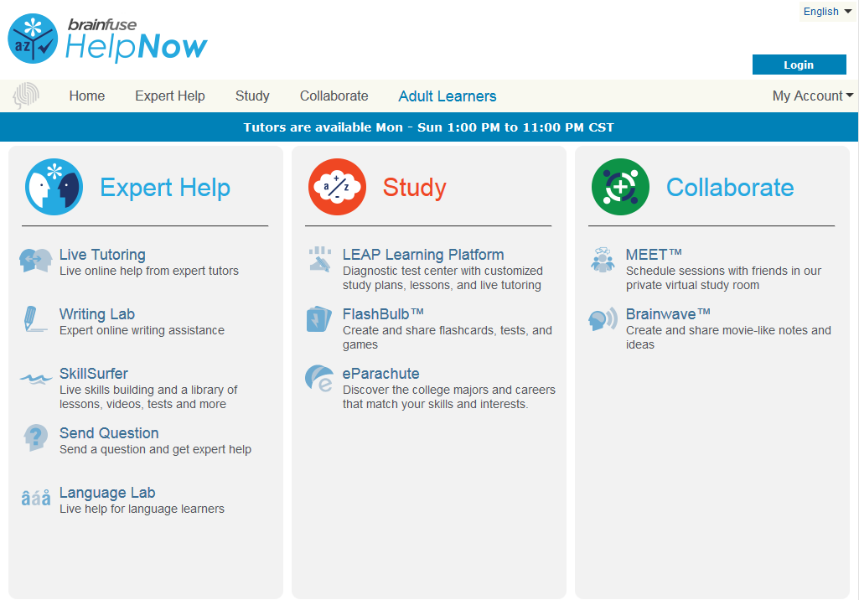

- Expert Help
Experience personalized eLearning by connecting with a live tutor
• Live Tutoring: Students submit a question in our online classroom and receive live, one-on-one assistance from a Brainfuse tutor.
• Writing Lab: Our writing tutors help students become better writers by providing constructive feedback, and assistance usually
within 24 hours of receiving a student’s submission.
• SkillSurfer: Our skills building service helps students master a concept or skill through state aligned online lessons with a live tutor.
HelpNow Skills Building has been designed for a variety of age groups and academic needs.
• Send Question: Students submit questions via our online form and a tutor will respond usually within 24 hours to the student’s
question.
• Language Lab: Students receive live online help with their Spanish language homework from our fluent Spanish-speaking tutors.
- Study
Powerful self-assessment and online learning tools
• LEAP Learning Platform: Diagnostic test center with detailed study plans, lessons and live tutoring.
• FlashBulb: Users can access and create interactive learning games, quizzes and flashcards.
• eParachute: Use eParachute to discover your strengths and unique talents to map out your future career.
- Collaborate
Form study groups, hold virtual office hours, work on class projects, and share knowledge with peers and instructors
• Meet: Schedule a live study group session with friends and instructors. Invitees receive the invite in their email inbox and simply
click on the Meet link to join the organizer. Attendees need not be Brainfuse users.
• Brainwave: Record movie-like whiteboard sessions to store solutions to homework problems, class projects, or any other
concepts that involve motion or sequencing.

Live Tutoring
Students submit a question in our online classroom and receive live, one-on-one assistance from a Brainfuse tutor.
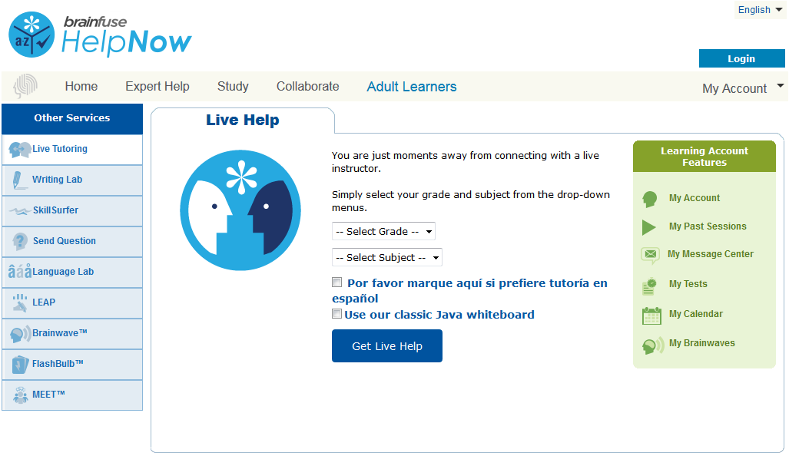
Select Grade
First, select the grade level.
(i.e. 3rd Grade)
Select Subject
Then, select the subject area under this topic that you would like to receive tutoring for.
(i.e. Math)
Finally, press Get Live Help and a live tutor will be with you shortly to assist you!
How to use the Whiteboard
The whiteboard area is on the left side. You can use your mouse to draw or the text tool to type on the whiteboard. Any images uploaded will appear on the whiteboard as well. Use the chat box on the right side to converse with your tutor. Type your message in the Chat Input Field to send your message.
The Whiteboard
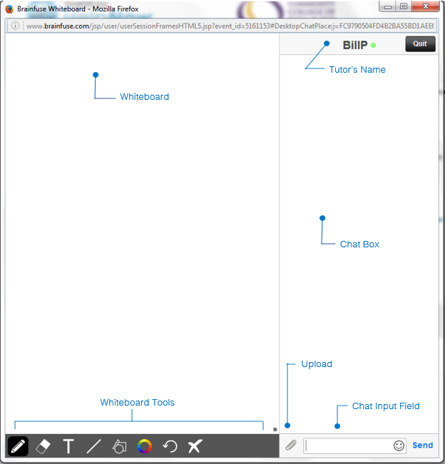

Whiteboard Tools (left to right)

PEN: Write/draw with your mouse


ERASER: Erase
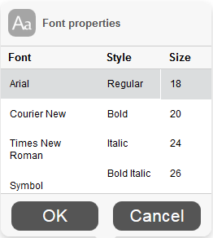
 TEXT TOOL: Click on the Whiteboard to start typing. Also expands to:
 SUPERSCRIPT: Changes text into superscript
 SUBSCRIPT: Changes text into subscript
 PASTE: Paste text onto the Whiteboard
 FONT: Change your font style and font size
 MATH SYMBOLS: Enter a mathematical symbol
 SCIENCE SYMBOLS: Enter a scientific symbol
 EQUATION EDITOR: Click on the Whiteboard and you can type mathematical equations, functions, and symbols in the available box. Press Enter to make the expression appear on the Whiteboard.

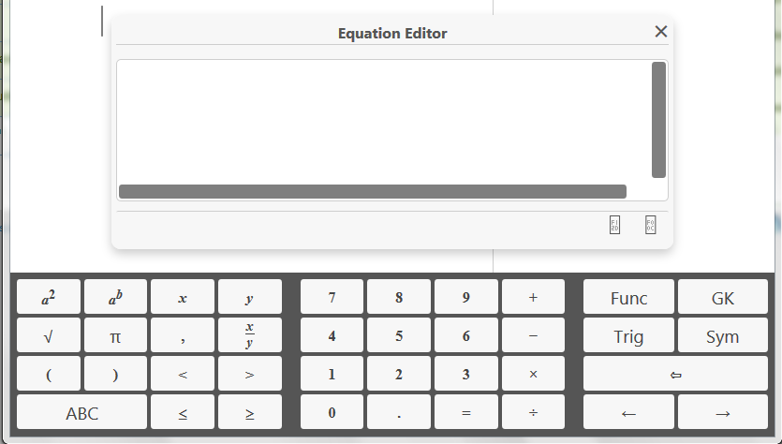

 LINE: Draw a straight line
 SHAPES: Select a shape from the menu to draw it on the Whiteboard
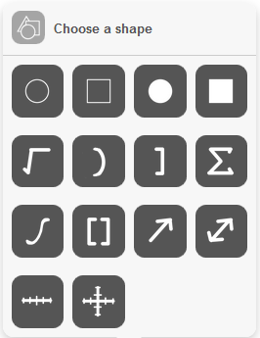

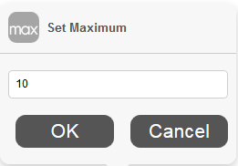


NUMBER LINES and GRAPHS:
Select MIN, MAX and INTERVAL MODE to adjust the minimum, maximum and interval values

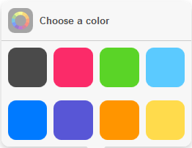
 COLOR PALETTE: Select from the menu to change pen/text color

 UNDO: Undo the last action

 CLEAR: Clears the entire Whiteboard
How to Take a Screenshot
Windows
Press ALT + PrtScn.
Mac
Press Command ⌘ + Shift + 3.
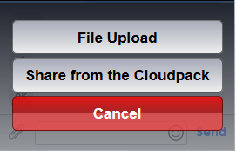
You may then copy (Ctrl + C / Command ⌘ + C) paste the screenshot onto the Whiteboard using the Paste button.
How to Upload an Image
UPLOAD: Click on the Upload button (bottom left of the Chat Box)

When this menu appears, select File Upload.

You can also upload from your Cloudpack if you have already stored documents or images there.
Then, click on Browse and search for the image in your computer and press OK.

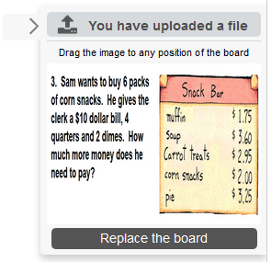

When your image finishes uploading, drag the image onto the Whiteboard to share it with your tutor.

Skillsurfer
Skillsurfer is an e-Learning service that helps students master a concept or skill through state aligned online lessons with a live tutor.
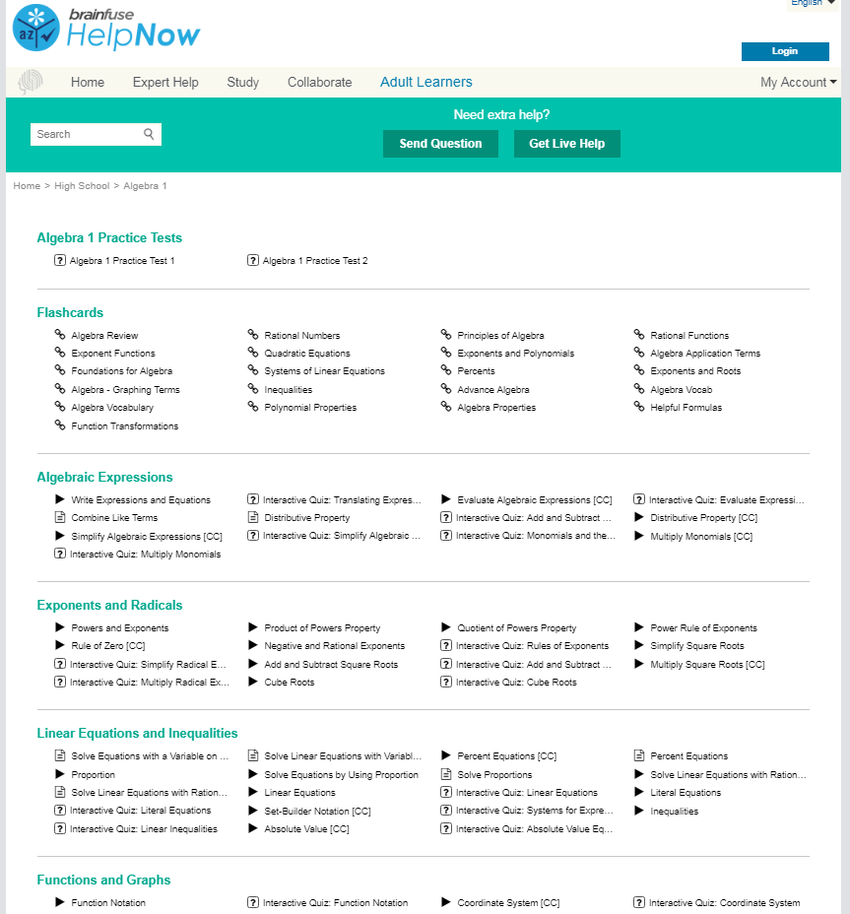
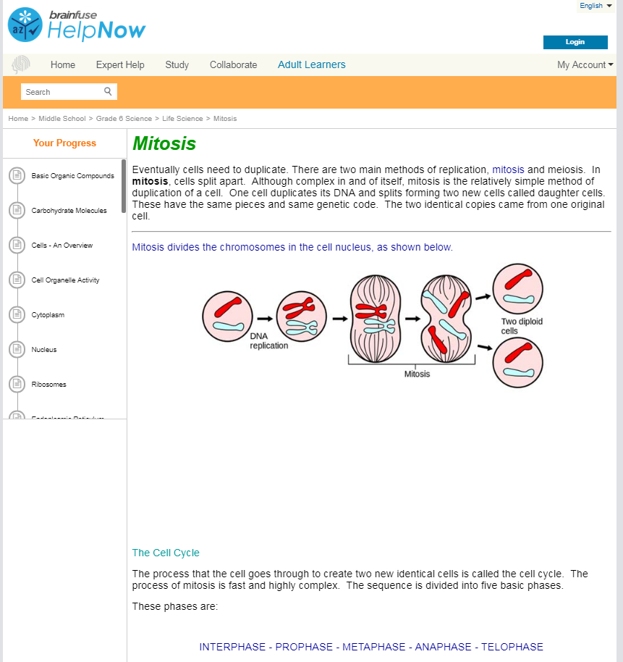
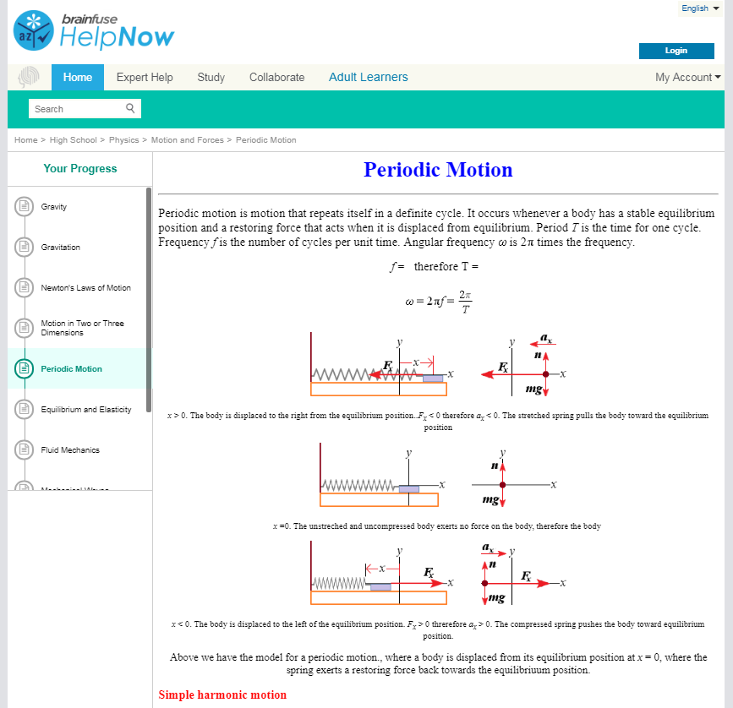
Click on Skillsurfer on the main menu on the Brainfuse homepage.
Select a subject. Each subject is further divided into subcategories. Choose a subcategory to view its lesson videos and notes.
View online lesson videos or read lesson notes to learn a new skill or review a previously learned concept. Skillsurfer learning content is always available, so feel free to return and continue where you left off.
Writing Lab & Send Question
Brainfuse HelpNow is the first service of its kind to offer live and offline writing assistance:
The Writing Lab and the Send Question options give users the freedom to receive assistance at any time of the without the need to connect to a live tutor. Users can submit papers through the Writing Lab for a detailed feedback. Send Question option is for non-writing assignments such as math or science. All reviews and comments from our tutors are found and stored in the Message Center which is found on the student homepage.
• Live Writing Assistance (For immediate help) – Our tutors provide live help throughout the various stages of the writing process to
help students with organizational structure, fluency, and coherence of ideas and style.
• Writing Lab (For more detailed help) – Students submit their writing through the Writing Lab. Our writing tutors will return the
document with detailed, constructive comments usually within 24 hours. The purpose of this service is not to write or edit papers
for students but to serve as a sounding board in order to help students better organize and present their thoughts. Our writing
experts are trained to guide you in your writing, focusing on voice, word choice, grammar, content, sentence variety, and
organization.
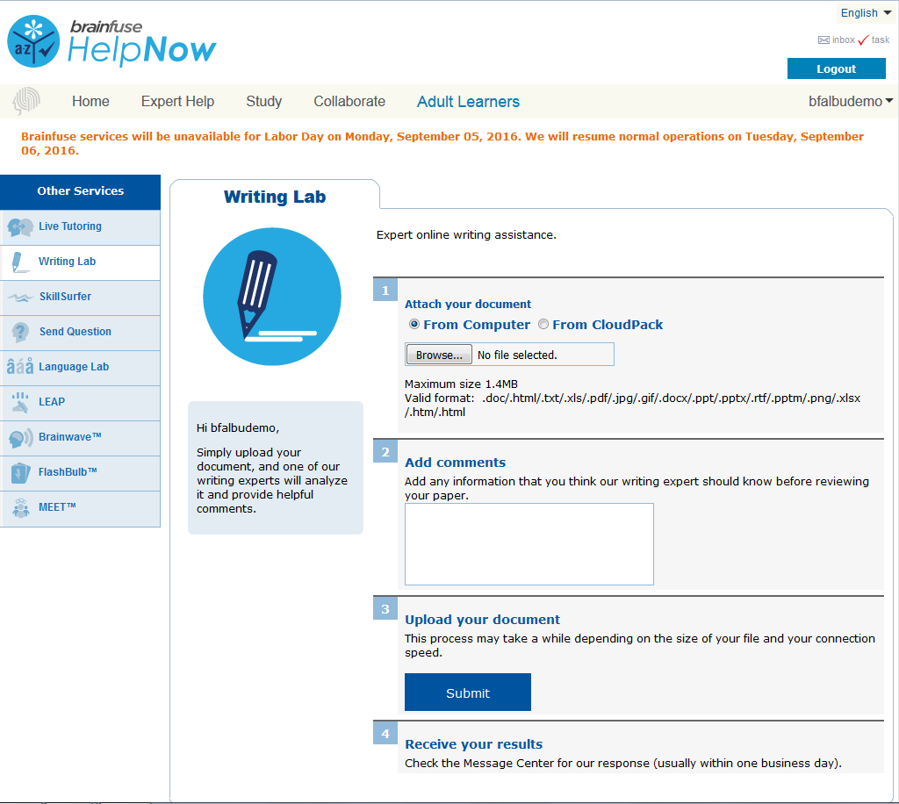

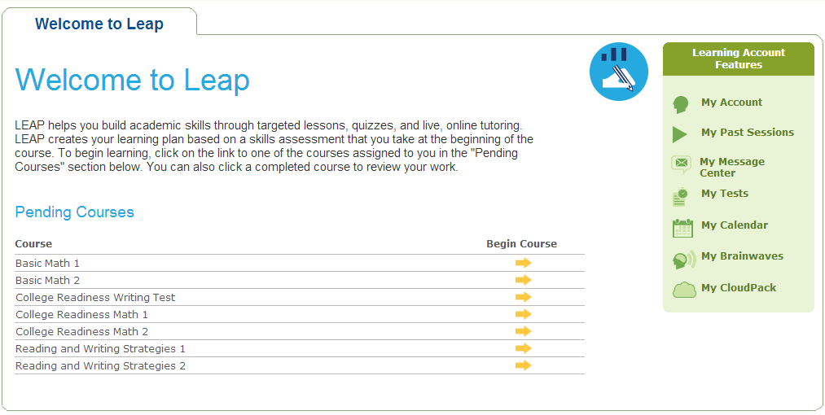
Leap Learning Platform
Leap is a diagnostic test center with customized study plans, lessons and live tutoring
Click on the LEAP icon from the main menu on the Brainfuse homepage and select a practice test (shown above).
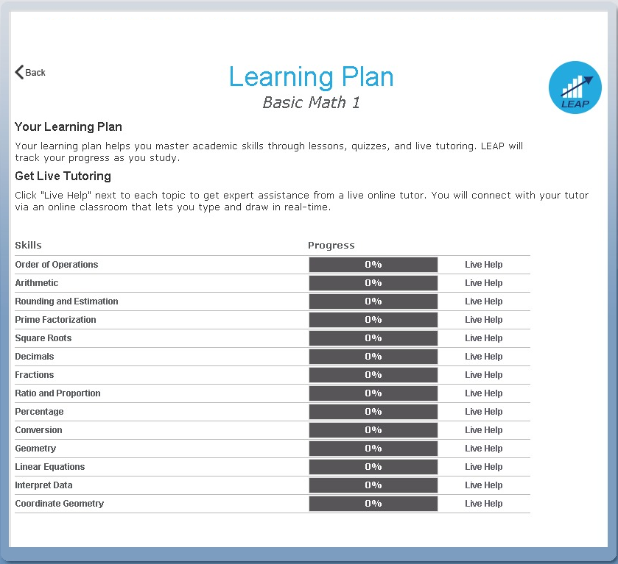
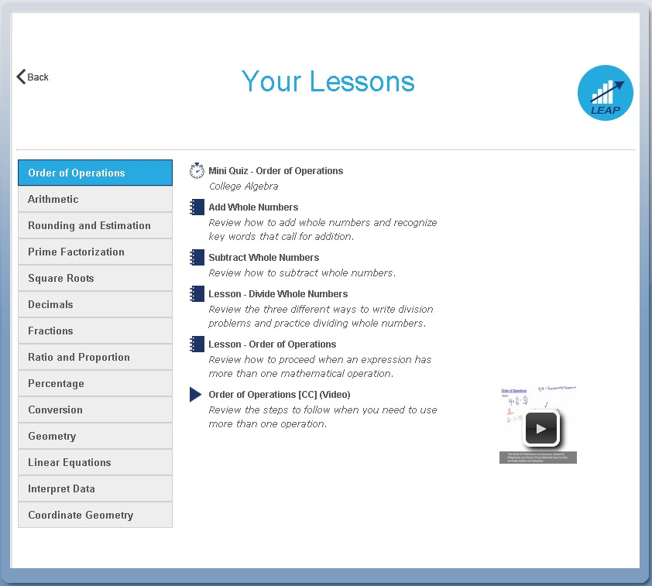

After completing the practice test, the list of targeted lessons, Each time a lesson, quiz or a video is viewed and checked off as
videos and mini quizzes appears along with the individualized completed, the colors on the chart will change to show progress.
progress chart. To redo the practice test or any of the mini quizzes, click on the
My Tests link found at the top of the page.

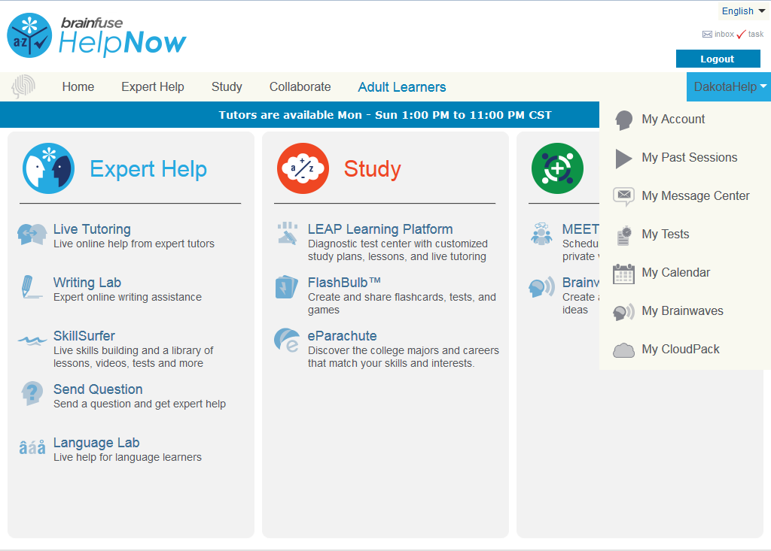
My Account
My Account is your personal Brainfuse profile and contains all past live tutoring sessions, questions/papers and tests taken. You can also view your scheduled MEET sessions here.

• My Past Sessions: A record of all previous live tutoring sessions. From this page, you can replay and e-mail your sessions to others.

• My Message Center: A record of all questions/papers sent to the Writing Lab and received from Brainfuse tutors.

• My Tests: All practice tests taken, along with the scores can be found here.

• My Calendar: Scheduled MEET sessions with live tutors can be found here.

• My Brainwaves: All of the Brainwaves that you created are shown here. You can also use the Brainwave library where you can
search for an existing Brainwave on a particular problem or a question created by other Brainwave users.

• My CloudPack: Create files or upload images, links, documents and load them onto the whiteboard.

Questions?



info@brainfuse.com
1-866-BRAINFUSE

